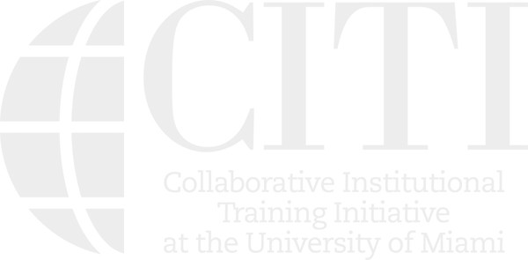COLLABORATIVE INSTITUTIONAL TRAINING INITIATIVE (CITI)
AU STUDENTS CURRICULUM COMPLETION REPORT Printed on 06/21/2014

LEARNER Kristian Secor (ID: 3184927)
PHONE 619-7278541
EMAIL ksecor@stu.argosy.edu INSTITUTION Argosy University EXPIRATION DATE 11/09/2017

AU STUDENTS
COURSE/STAGE: Basic Course/1
PASSED ON: 11/10/2012
REFERENCE ID: 9089349

REQUIRED MODULES | DATE COMPLETED | SCORE
History and Ethical Principles - SBE | 11/10/12 | No Quiz
Assessing Risk - SBE | 11/10/12 | 5/5 (100%)
Informed Consent - SBE | 11/10/12 | 5/5 (100%)
Argosy University | 11/10/12 | No Quiz

For this Completion Report to be valid, the learner listed above must be affiliated with a CITI Program participating institution or be a paid Independent Learner. Falsified information and unauthorized use of the CITI Progam course site is unethical, and may be considered research misconduct by your institution.

Paul Braunschweiger Ph.D. Professor, University of Miami
Director Office of Research Education
CITI Program Course Coordinator

