Marvel Insider
Marvel Insider located at Marvel.com/insider is the website for Marvel Entertainment’s Loyalty rewards program. Users earn points for anything from purchasing digital Marvel comics online, to watching trailers for Marvel shows or following Marvel Entertainment on Twitter. Users go to Marvel insider to find activities to earn more points and spend their current points on rewards. Marvel Insider is part of a closely linked group of other Marvel websites including Marvel’s main website Marvel.com, Marvel Unlimited and Marvel’s digital comic book store.
Marvel Insider works to cross promote Marvel’s products and push Marvel’s brand forward by creating a place where consuming new Marvel news and products has been incentivized. New content is added weekly which allows new comics to be added as soon as they hit shelfs. The real strength of Marvel Insider is it pushes fans of one form of Marvel media to sample and consume products from other areas of Marvel Entertainment. For example, if a user is only a fan of Marvel’s comic books they are rewarded at Marvel Insider for watching trailers for Marvel television and movies, trying Marvel’s mobile games and for following Marvel Entertainment on social media.
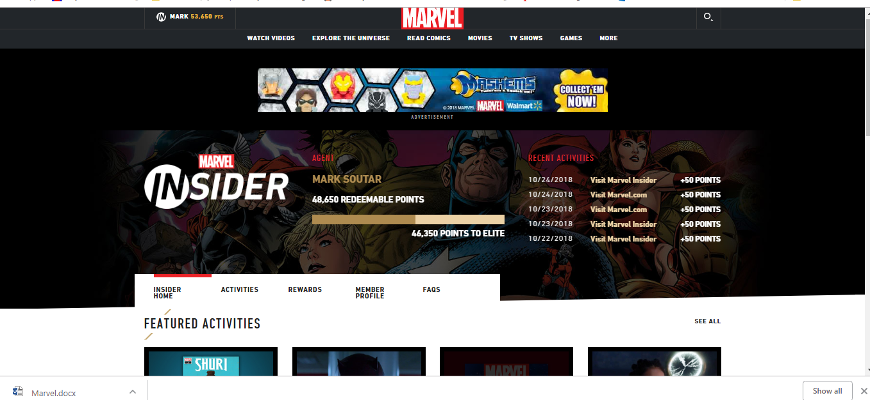Marvel Insider’s Desktop Home Page
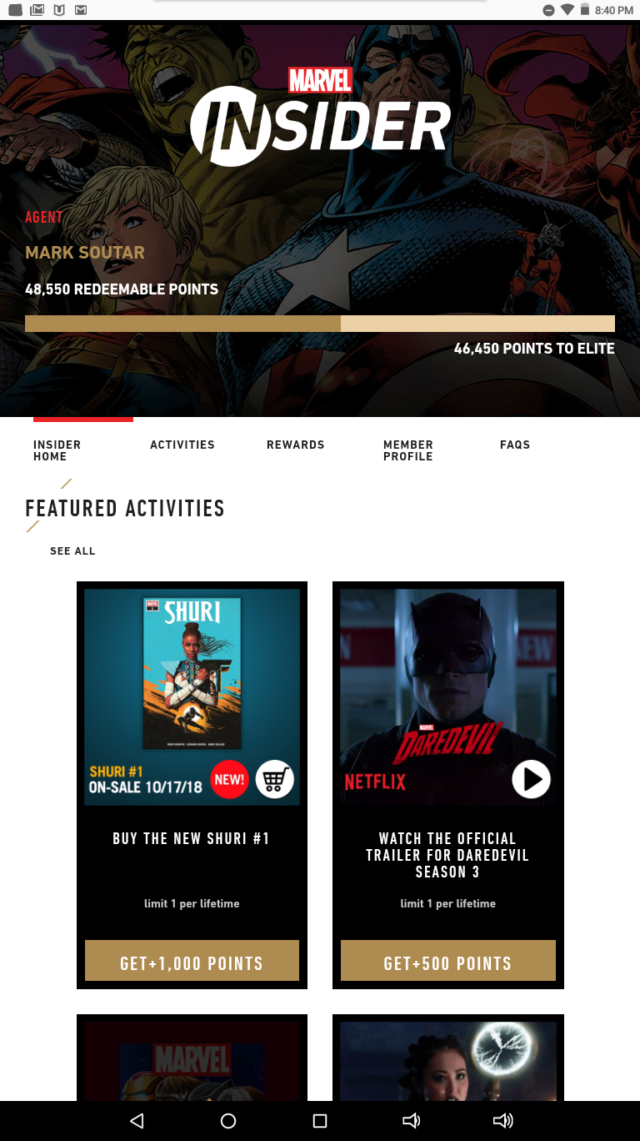
Marvel Insider’s Tablet Home page
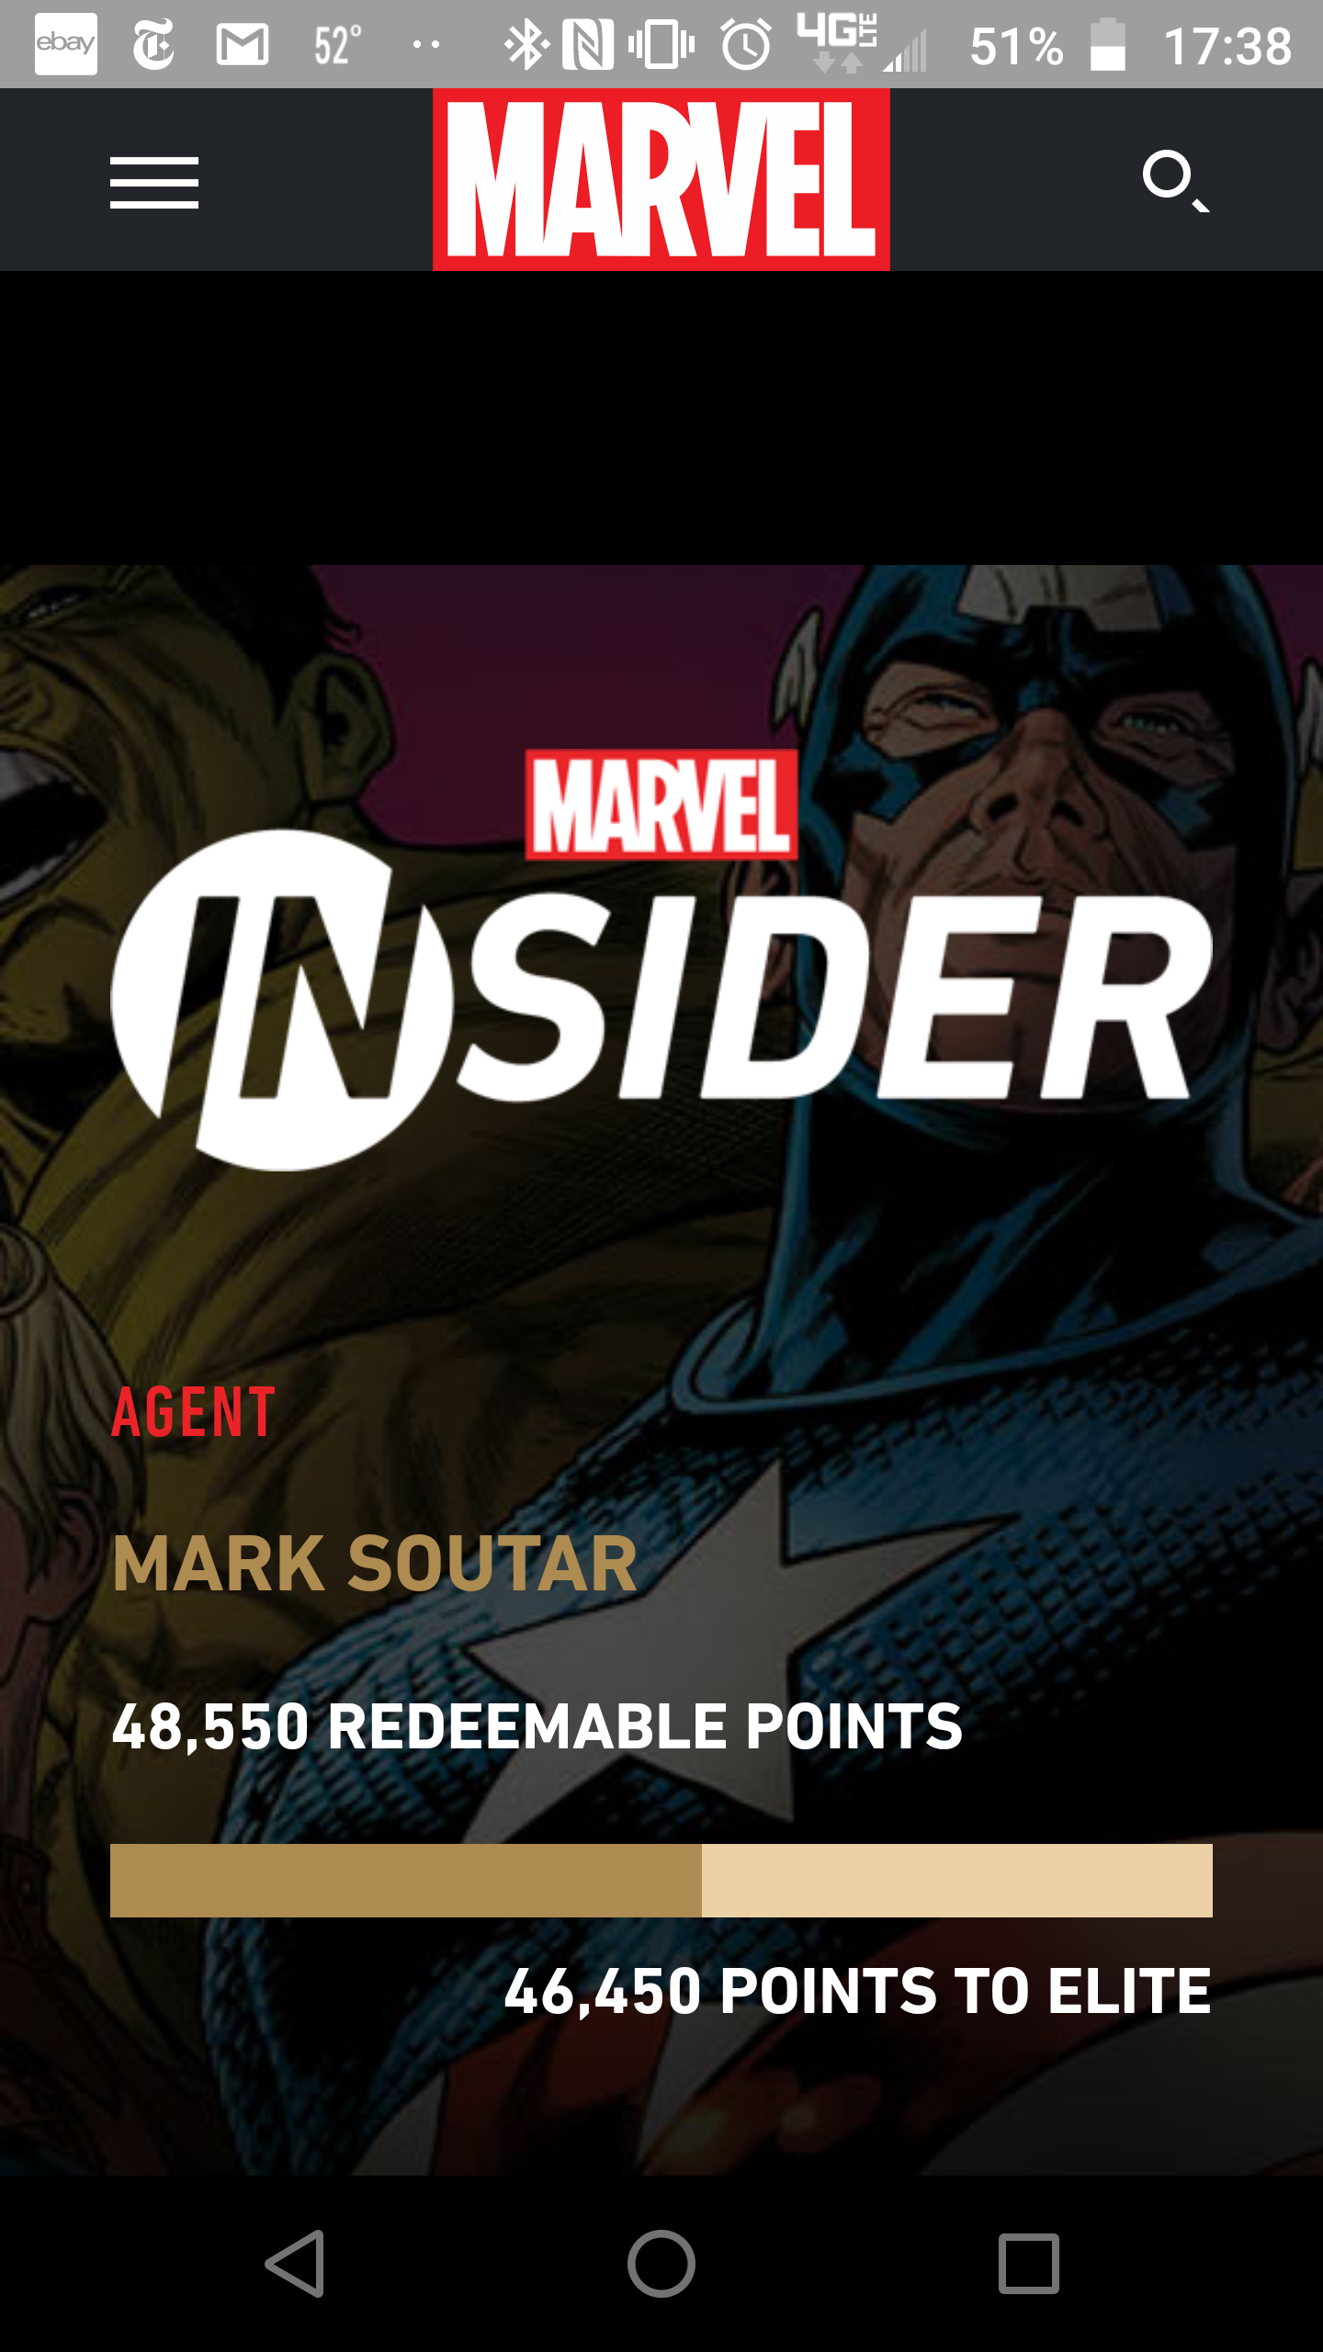
Marvel Insider’s Mobile Home page
Problem 1
The first issue to be addressed is the layout of Marvel insider on the mobile page. Below illustrates how items are laid out on the Marvel Insider desktop page. The item size is optimized for the screen size. Items are laid out in rows and the desktop screen size is utilized to display items cleanly and many of the categories show most items without having to scroll.
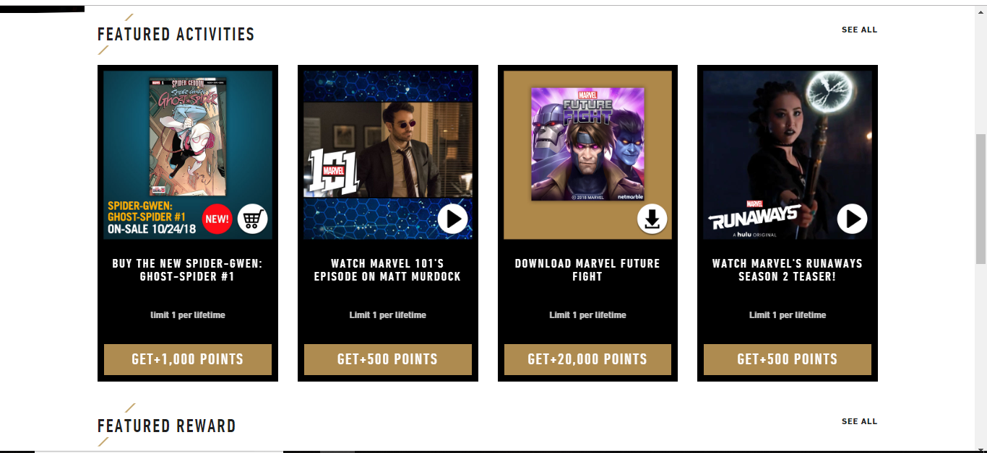
Desktop Featured Activities
Why it’s a Problem
The mobile site however makes it difficult to navigate through categories to search for specific content due to the size of each item on a mobile screen. Content is added and removed from the store every Wednesday (The day new comic books are released in stores). Some categories swell with the largest I have observed over the past 3 weeks having up to 20 items. Each item takes up almost the entire mobile screen which causes an excessive amount of scrolling for users and makes finding a particular item difficult if a user does not know which category it is in.
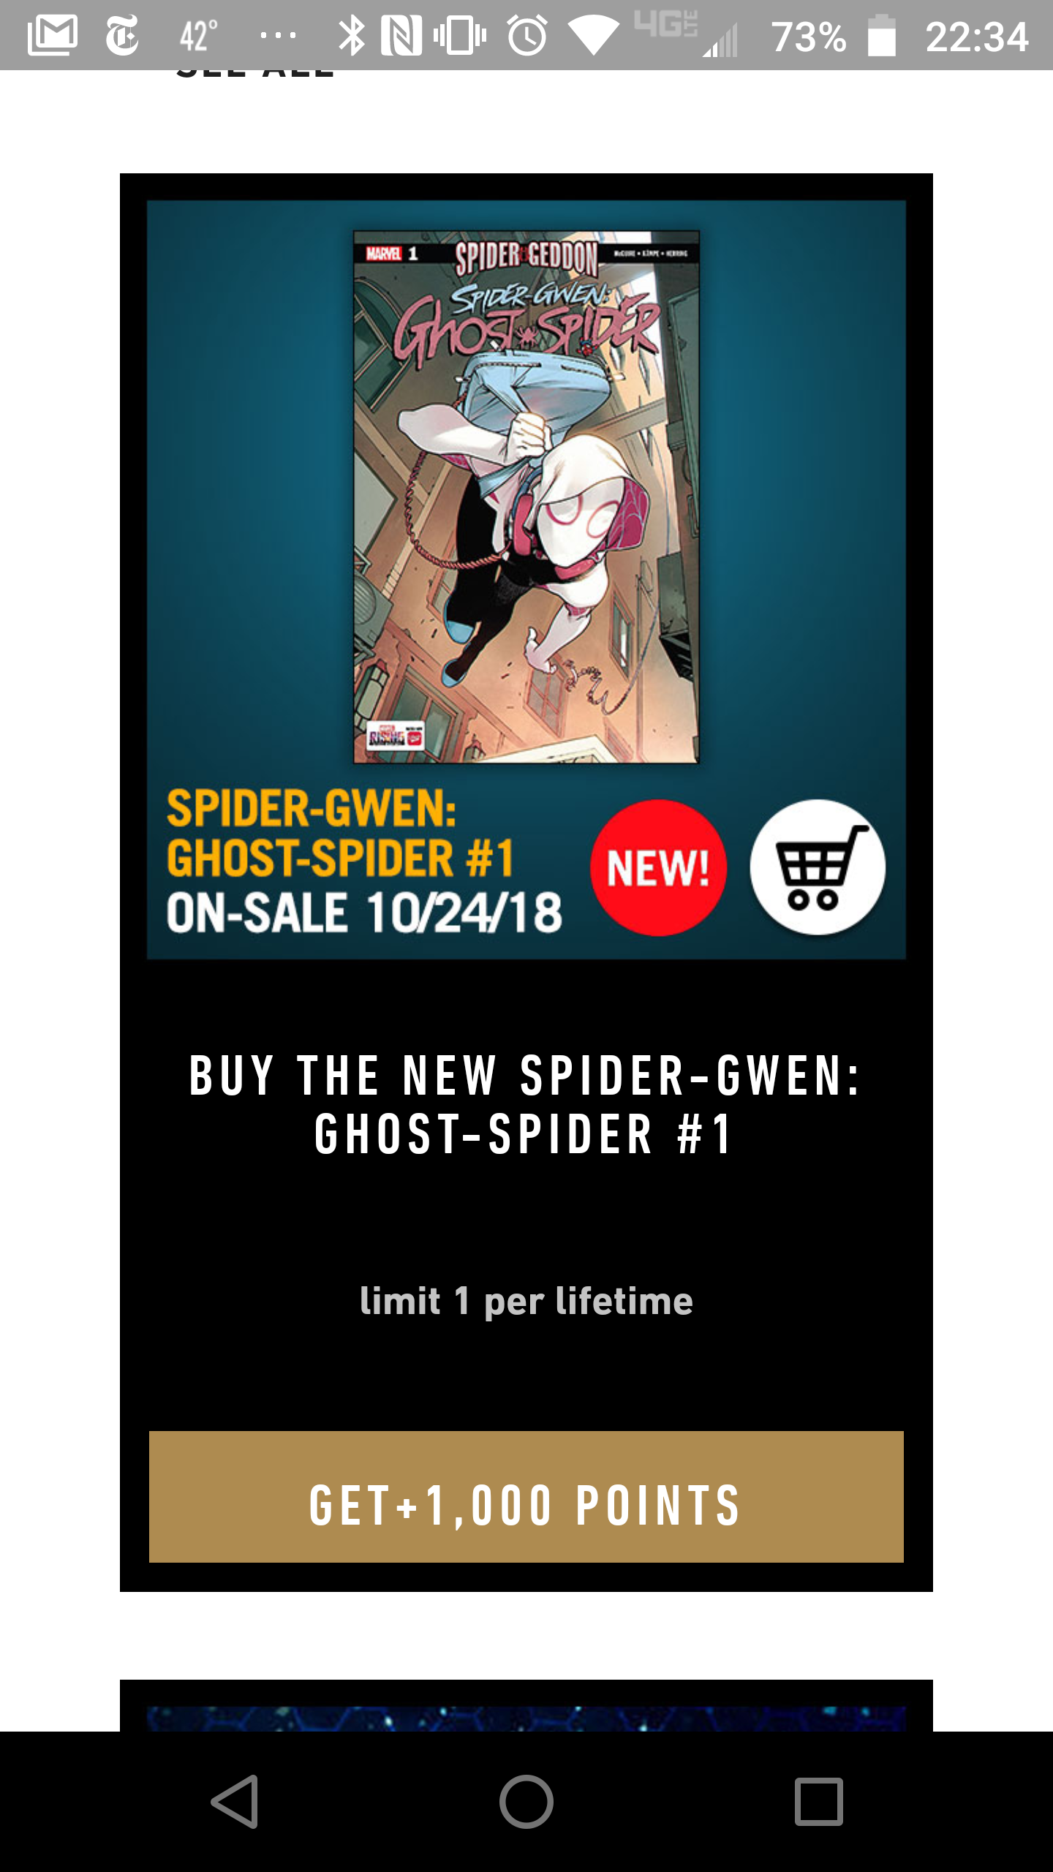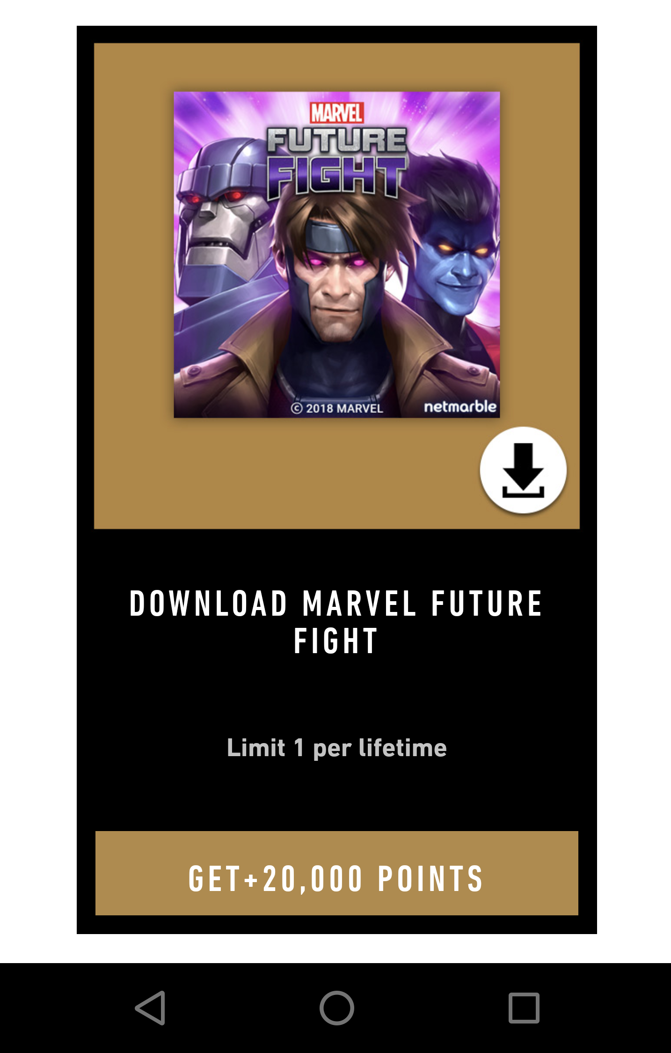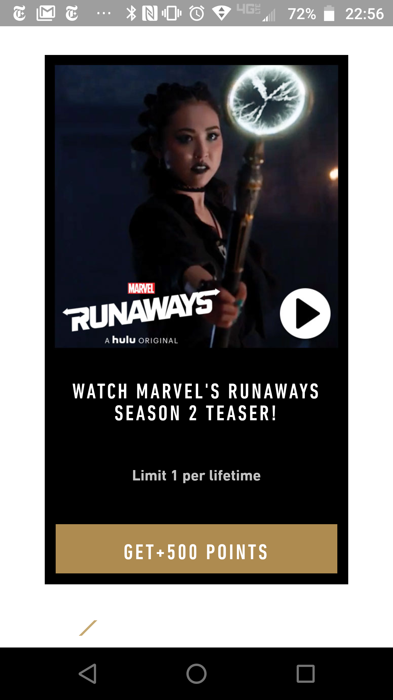
Mobile Featured Activities
Solution
To fix this Marvel Insider could resize items to make them fit mobile screens more effectively however it is difficult to find a size that will display adequately across so many different sized mobile devices. Marvel Insider while selecting a category could give the option to the user of selecting how content is displayed. Users could select the option of how Marvel Insider displays content currently, they could choose to display a thumbnail image with the text below it or they could display a text description without any image. This enables the user to select the best visual interface that fits their needs and enables them to find content more quickly and efficiently.
Problem 2
Another obstacle to being able to navigate Marvel Insider more efficiently is the misleading category titles. For example, if you want to look at the different activities you can do to earn points you click on “Activities” and the sub menu that pops up includes “Get Started” which based on the title most would assume is an explanation of what Marvel Insider is and how you earn points. Instead it is a list of social media platforms that if you follow or like or interact with Marvel on in some way, you earn points. The next category is called “Latest at Marvel” Which when I clicked on it I assumed was going to be the newest content from across all the Marvel Insider activities. However, it is a list of all the trailers and teasers for Marvel’s movies, TV shows, cartoons and podcasts. “Comics” is the next and category here you can find comic books, comic previews, comic collections and what is coming to Marvel Unlimited this month. Marvel unlimited is a paid subscription service, it works in a similar way to Netflix but for comics. The Marvel Unlimited preview feels like it would be more at home in the “Latest at Marvel” category if it truly included just new Marvel content, and the points earned for subscribing to Marvel Unlimited would fit better in the “Get Started Category. The last and best named category is “Games”, and this is where any points a user can earn through Marvel related app games can be found.
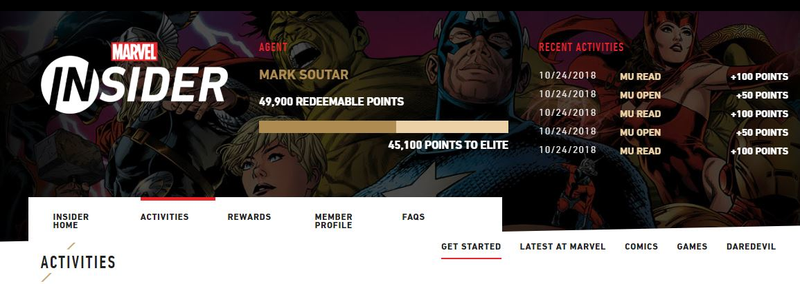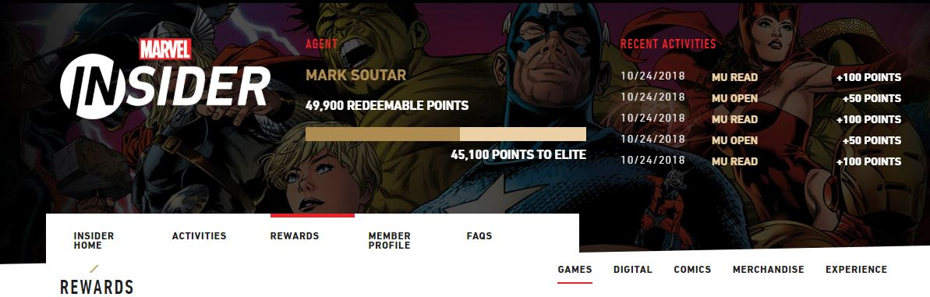
Marvel Insider Categories
Why it’s a Problem
The poorly named categories can create significant confusion for users as they navigate the site. Poor labeling can create difficulty finding the activities and rewards a user is looking for. Too much difficulty locating items, and too much time spent searching a site without finding what they are looking for will eventually cause many users to stop utilizing a website entirely.

Solution
The solution to this is to relabel the categories under “Activities” and “Rewards”. The first category would be “Latest at Marvel” and all new content to Marvel Insider that week would be found here. Next category would be “Social Media” and here all the points that can be earned for adding Marvel Entertainment related accounts on social media would be found here. The next category would be “Comics” in this category all points that can be earned through buying Marvel digital comics would be found here. “Games” would be the category that all points that can be earned playing and downloading Marvel mobile games would be found and finally “On Screen” is where all activities pertaining to Marvel movies, television shows and cartoons would be found. Categories for “Rewards” would remain unchanged except for “Digital” would be renamed “Themes and Wallpapers”. These changes will help users be able to find what they are looking for more quickly and easily as the category names are more intuitive and user friendly.
Problem 3
The search bar on Marvel Unlimited is a significant problem. On the desktop site the search bar at the top of the screen is embedded with the following links “Watch Videos”, “Explore the Universe”, “Read Comics”, “Movies”, “TV Shows”, “Games” and “More” with a Hyperlink to the main Marvel.com page ebbed in the Marvel Logo. There is no visible indication on the page the header containing these links is not part of the Marvel Insider page and instead the links take you to pages on the main site. Anything you search using the search bar searches Marvel.com it does not search Marvel Insider. Searching for unique items on the Marvel Insider page yields no results. The search bar on the mobile is located in the same place the upper left corner, it is not near any other links and it also has no indication it is not part of the Marvel Insider page but instead searches Marvel.com. The search bar on the mobile site is broken with every search I attempted over a 2 week period yielding an error message.

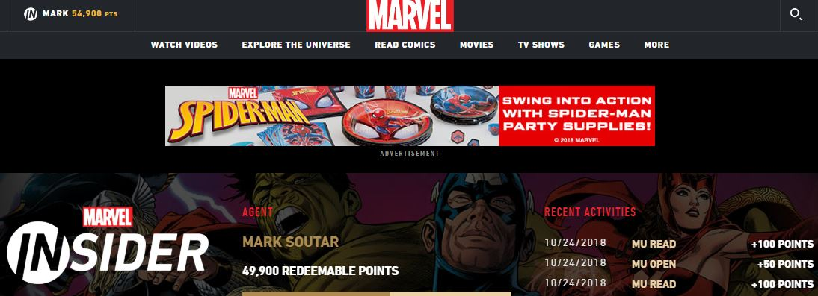
Header containing the search bar on desktop page

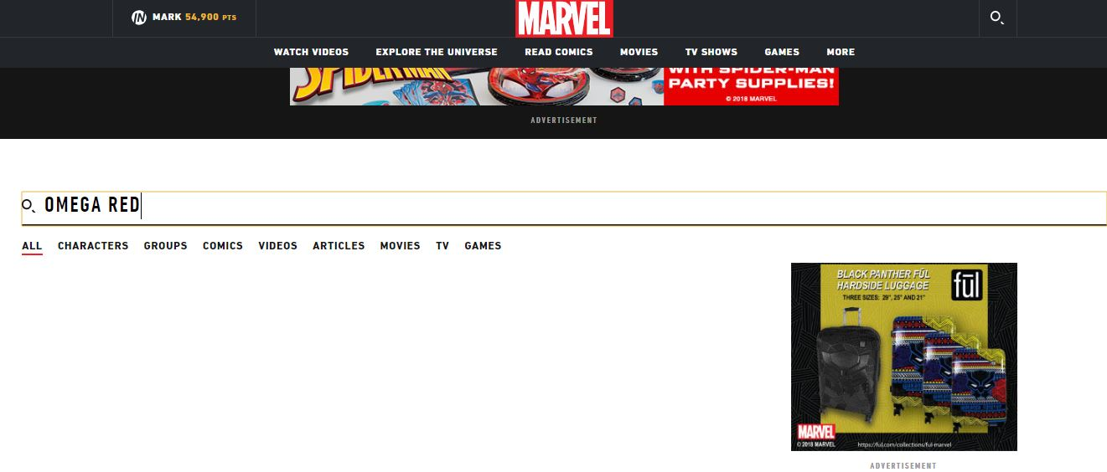

Search bar displaying filters for Marvel.com results
The search bar on the mobile site
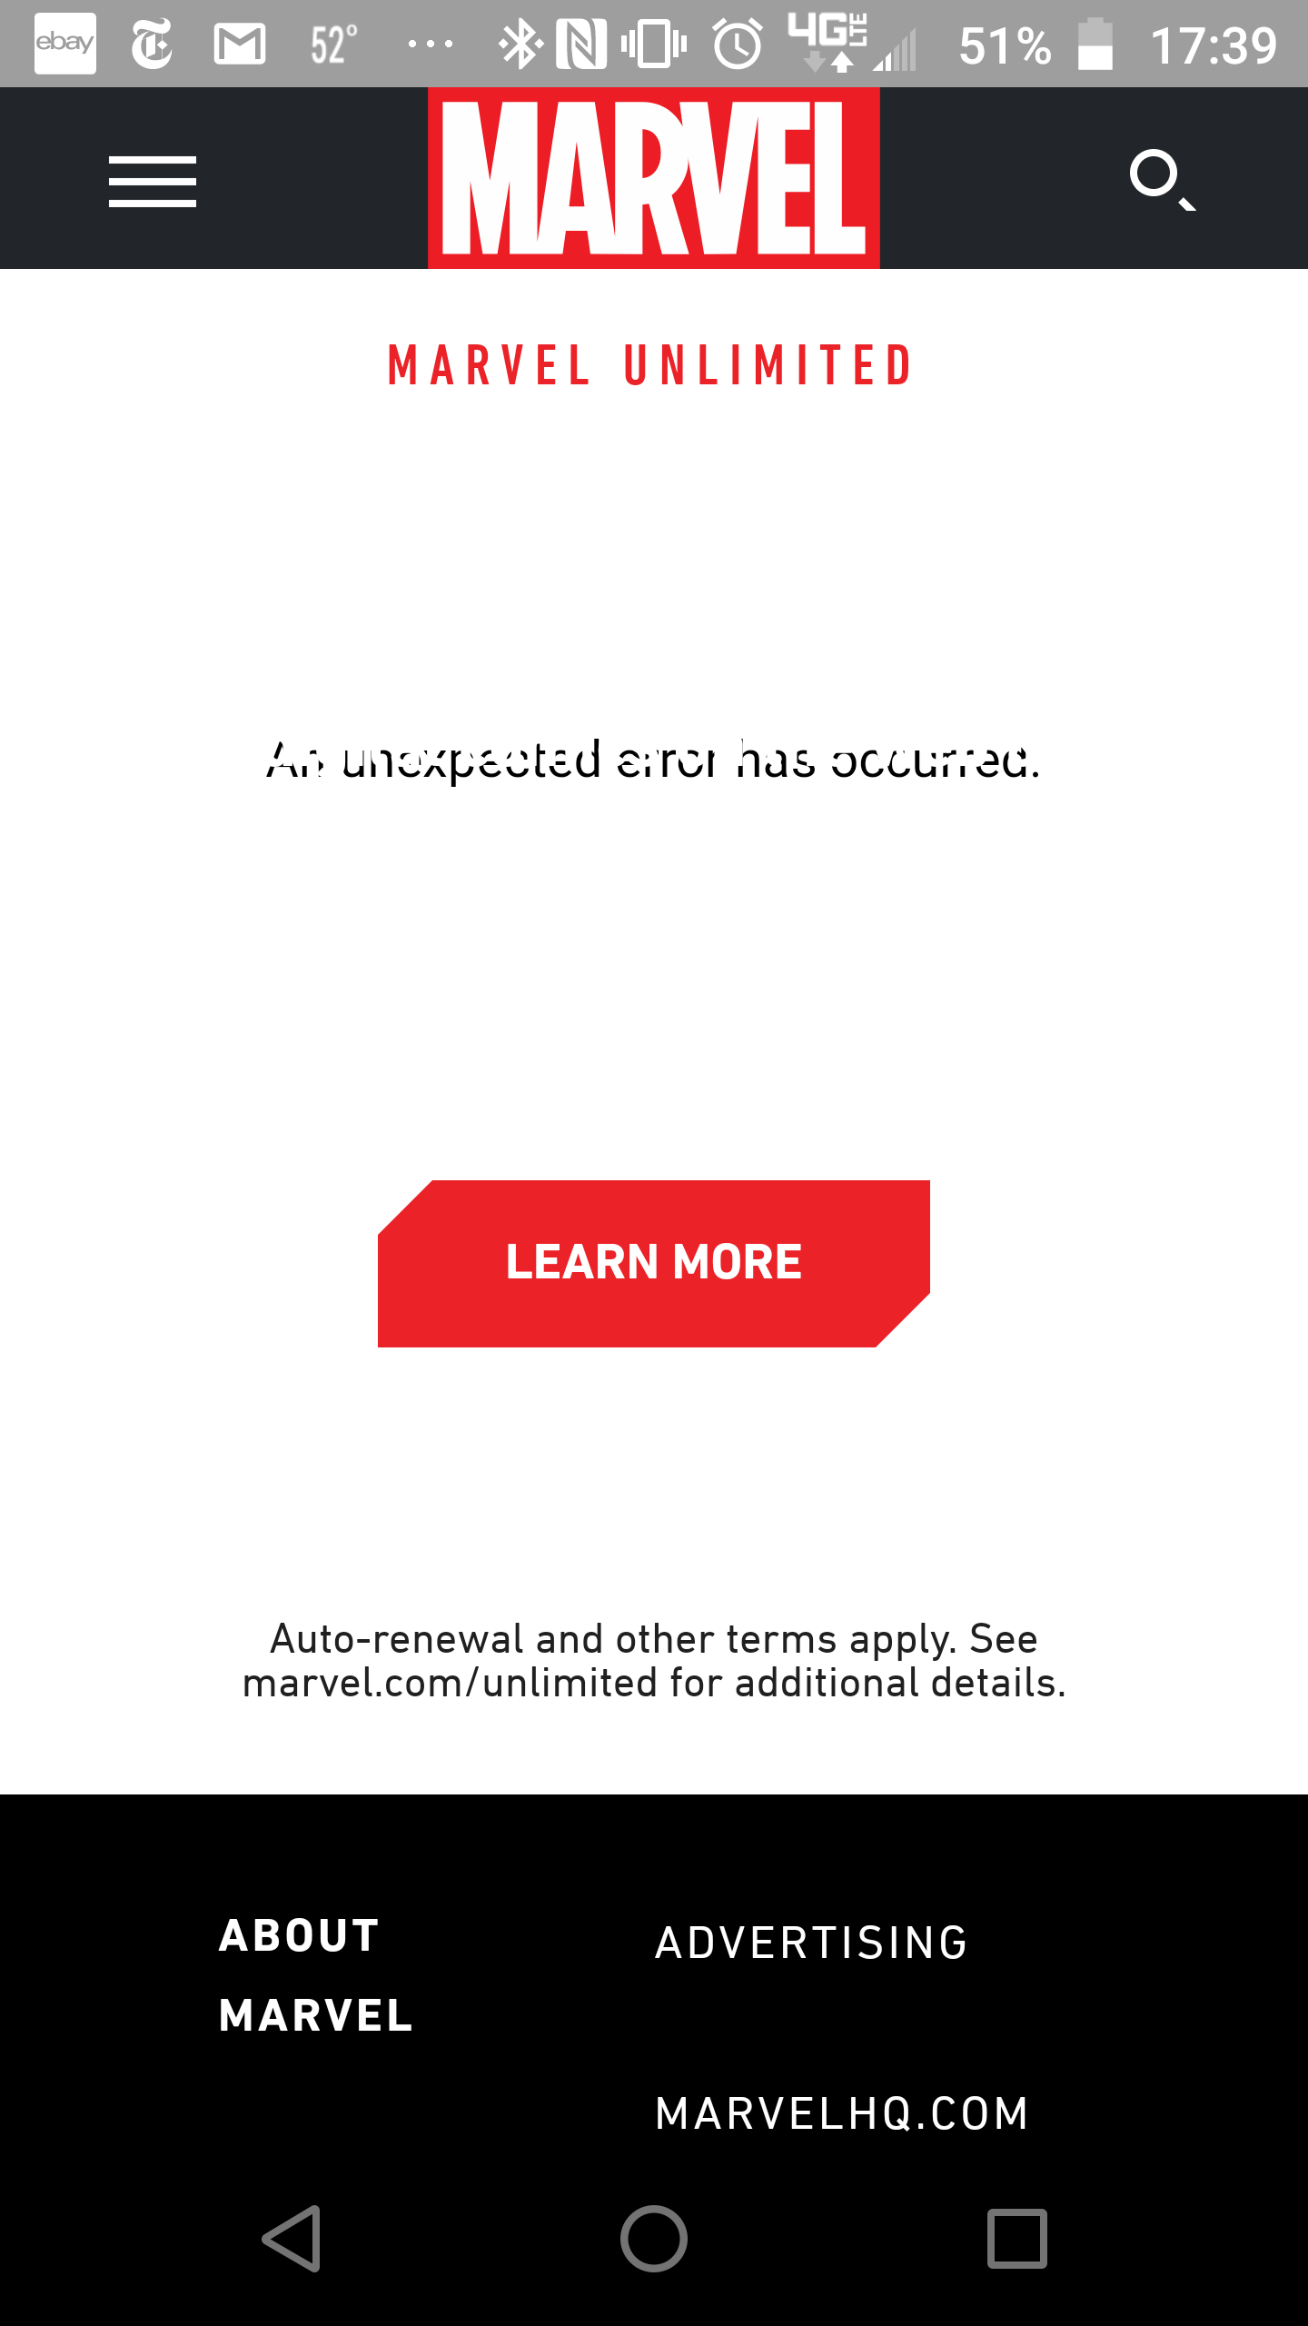
Error Message on mobile site
Why it’s a Problem
This is a serious issue that there is no indication that the search bar is not native to the Marvel Insider site and only searches Marvel.com. The search bar along with the other links at the top of the page will all redirect the user off the Marvel Insider page. If the user was unaware of this when utilizing the search bar, when they found no Marvel Insider results to their searches they would erroneously assume that was because the content was not on Marvel Insider not that the search bar was searching elsewhere. The search bar being completely broken on the mobile page is a significant as it points to a major design flaw on the website. Few things destroy a user’s impression of a website more than a broken component.
Solution
A very simple fix to these problems is to remove the search bar and the rest of the Marvel.com links at the top of the page excluding the Marvel Logo at the top of the page. These links and the search bar at best are a distraction for the user that creates clutter at the top of the page. Most likely they will sabotage a user’s experience by unexpectedly redirecting them off the page or in the case of the search bar return search results to a different page. By removing these links no functionality is lost and if a user wants to use any of those links they can click on the link in the Marvel Logo taking them to the main Marvel site where the links we removed are in the header.
Problem 4
The purpose of Marvel Insider is to increase user’s awareness and consumption of Marvel related products through cross promotion of different Marvel media and products. Marvel has always made an effort to direct attention to it’s line of comic books to fans of Marvel’s other products. That goal represents a missed opportunity on Marvel Insider.
Why it’s a Problem
The description for many of the items on Marvel insider is barebones and does not include a robust description of the item or the characters represented. Below is an example of a digital comic offered as a reward on Marvel Insider. It includes a thumbnail of the issue on a mobile device, a succinct description of the issue and a disclaimer about the digital code. It does not give any additional information about the characters, the universe they inhabit or where additional content can be purchased.
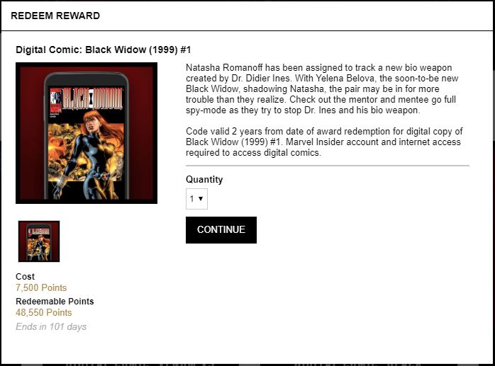

Solution
Marvel.com has lengthy biographies for many of it’s characters, its entry on Black widow for example is several pages long and includes a physical description and relevant statistics. Marvel Insider could add a hyperlink to all of it’s products linking to any characters that appear in that item. Marvel.com has also compiled detailed lists of characters’ comic book appearances and major story arcs, Marvel insider could also insert a link to that page as well to expose the user to more content associated with what they Marvel properties they are interested in and interface with other Marvel websites and content.
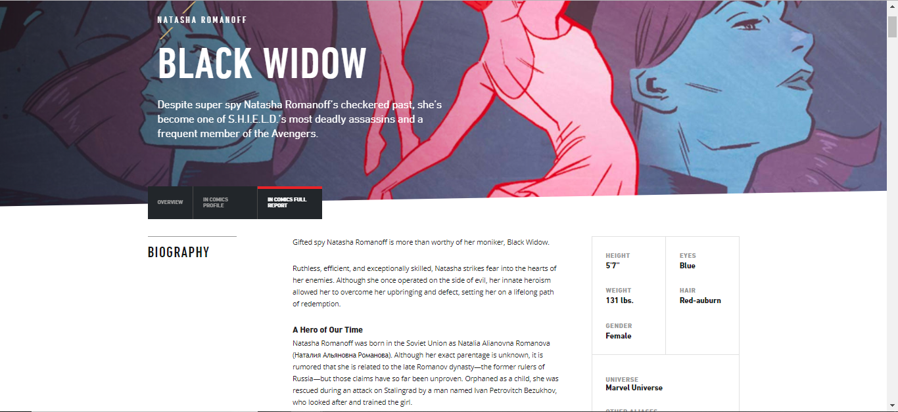
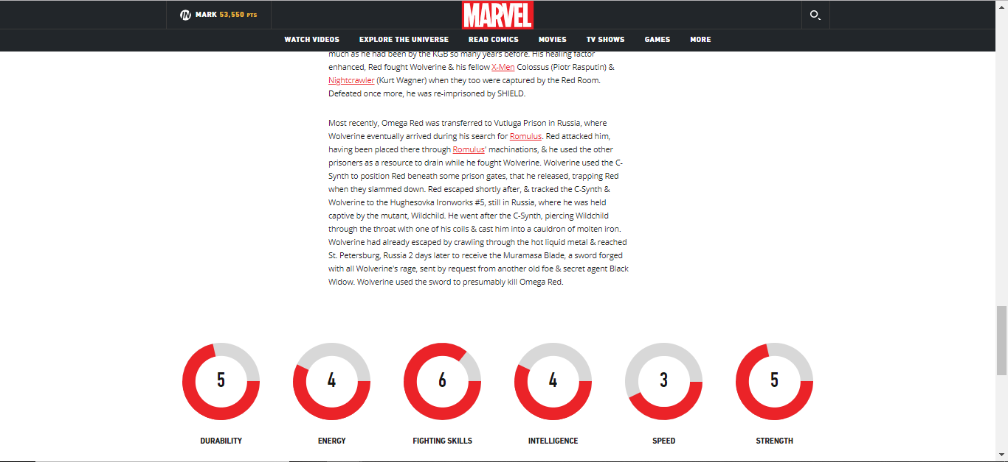
The first and last page of Black Widow’s Marvel.com biography
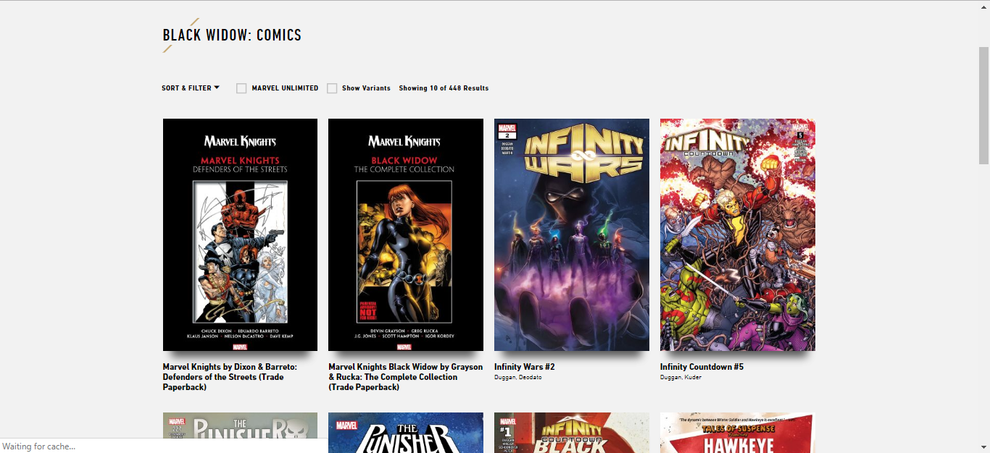
List of Black Widow comics available for digital purchase.
Conclusion
With the changes recommended here Marvel Insider can create a better user experience for their consumers. They can create a more organized webpage with better category names and descriptions. Marvel Insider can reduce scrolling and allow the user to select different ways to view items ensuring an optimal experience. Marvel Insider can reduce clutter by removing the links and search bar from the top of its page, and cross promote more of its products by including links to their extensive database of Marvel characters and comics in its item descriptions.

